Thermal design of shell-and-tube heat exchangers

ABSTRACT

Thermal design of shell-and-tube heat exchangers (STHEs) is done by sophisticated computer software. However, a good understanding of the underlying principles of exchanger design is needed to use this software effectively.

This article explains the basics of exchanger thermal design, covering such topics as: STHE components; classification of STHEs according to construction and according to service; data needed for thermal design; tubeside design; shellside design, including tube layout, baffling, and shellside pressure drop; and mean temperature difference. The basic equations for tubeside and shellside heat transfer and pressure drop are well known here we focus on the application of these correlations for the optimum design of heat exchangers. A follow-up article on advanced topics in shell-and-tube heat exchanger design, such as allocation of shellside and tubeside fluids, use of multiple shells, overdesign, and fouling, is scheduled to appear in the next issue.

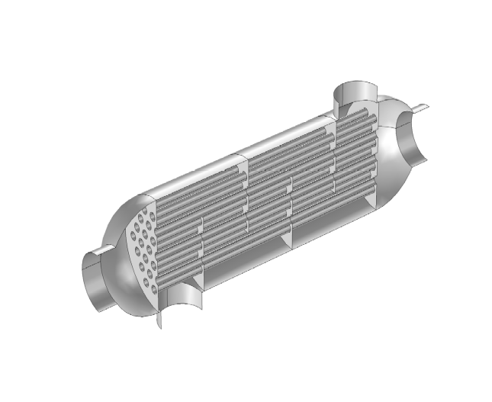
Design of Shell and Tube

